**PowerShell Remote Management (WinRM) Configuration Documentation**

**1. Enable-PSRemoting**

The Enable-PSRemoting cmdlet configures the computer to receive remote PowerShell commands. It performs the following tasks:

**Enable-PSRemoting**

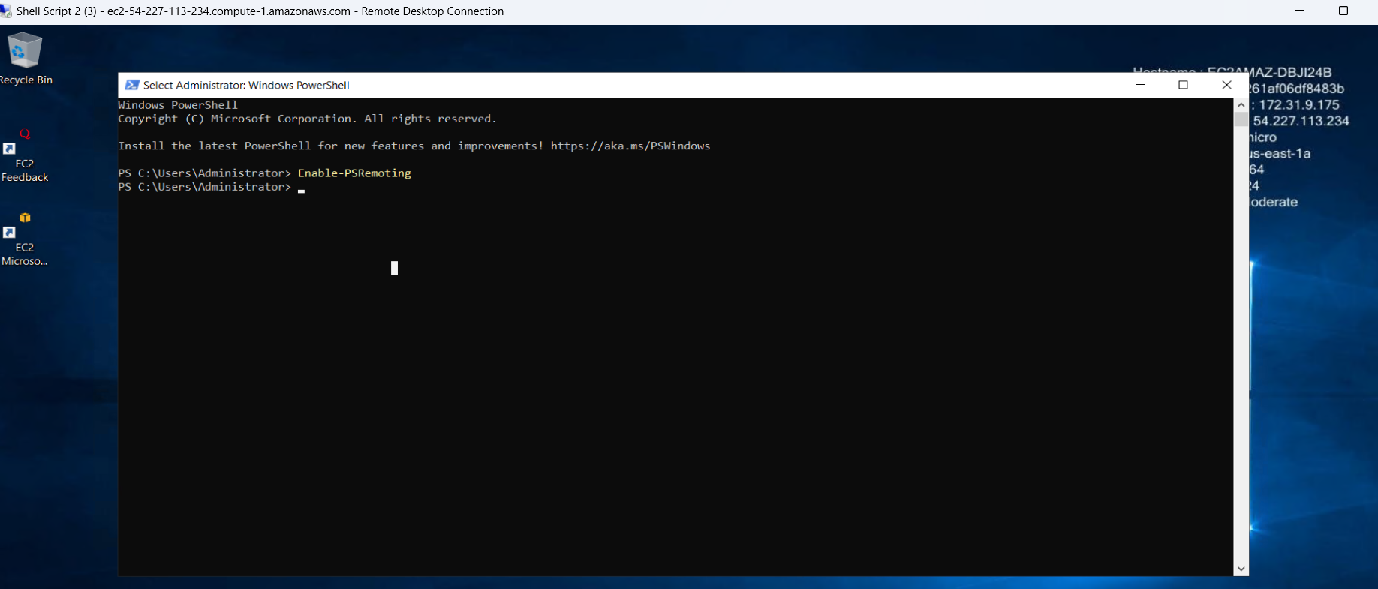

**2. Set Network Connection Profile to Private**

This command sets the network connection profile to Private, allowing private network communication.

**Get-NetConnectionProfile | Set-NetConnectionProfile -NetworkCategory Private**

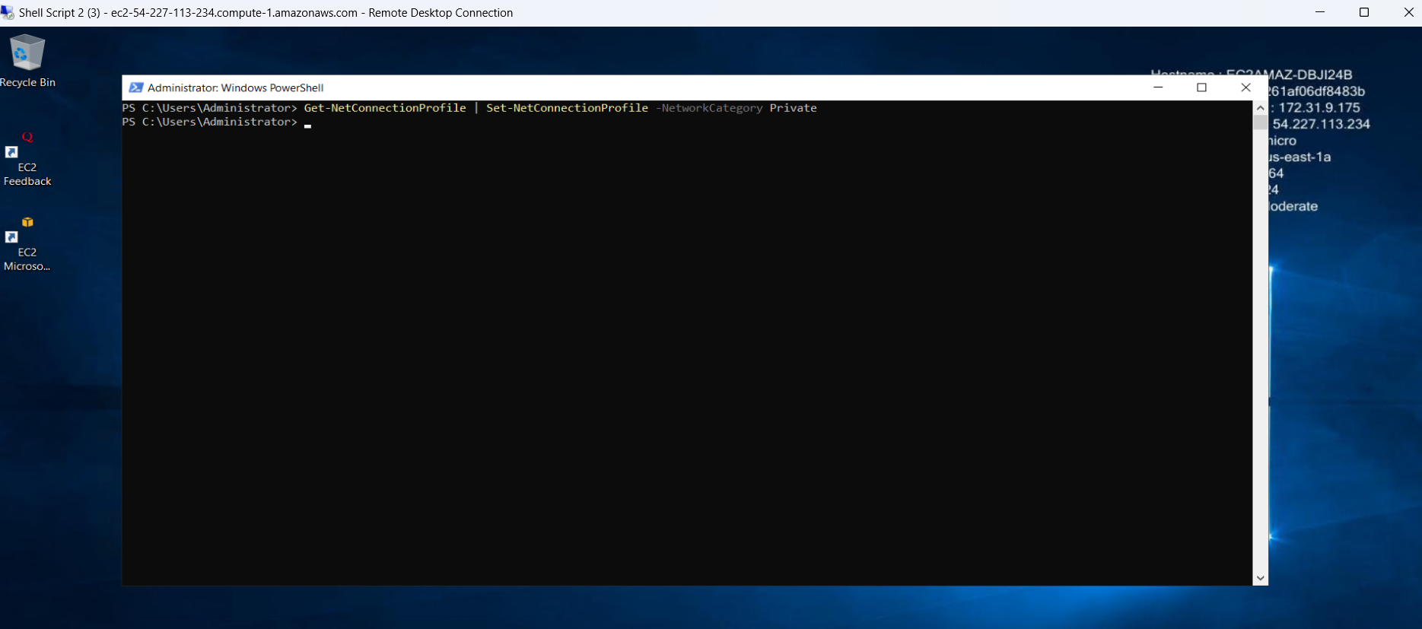

**4. Set NetFirewallRule for WINRM-HTTP-In-TCP**

Configures the firewall rule "WINRM-HTTP-In-TCP" to allow incoming TCP connections on any remote address.

**Set-NetFirewallRule -Name "WINRM-HTTP-In-TCP" -RemoteAddress Any**

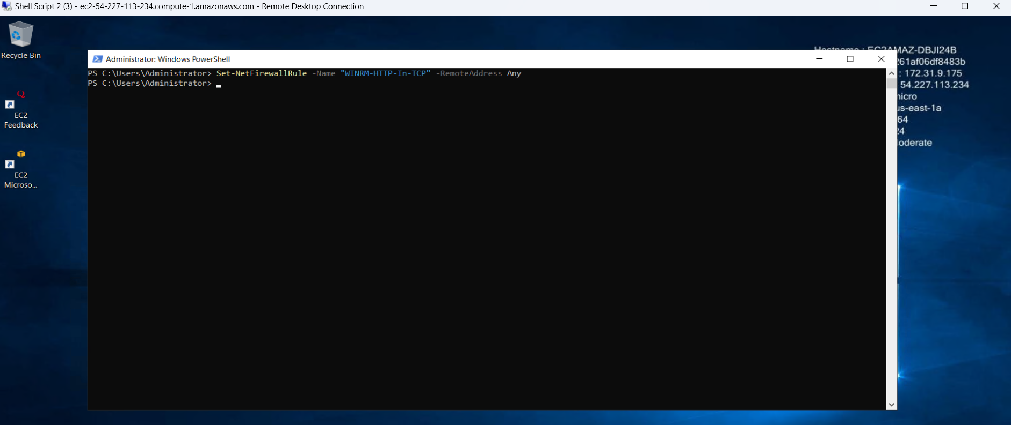

**5. Set NetFirewallRule for WINRM-HTTP-In-TCP-NoScope**

Configures another firewall rule "WINRM-HTTP-In-TCP-NoScope" to allow incoming TCP connections on any remote address.

**Set-NetFirewallRule -Name "WINRM-HTTP-In-TCP-NoScope" -RemoteAddress Any**

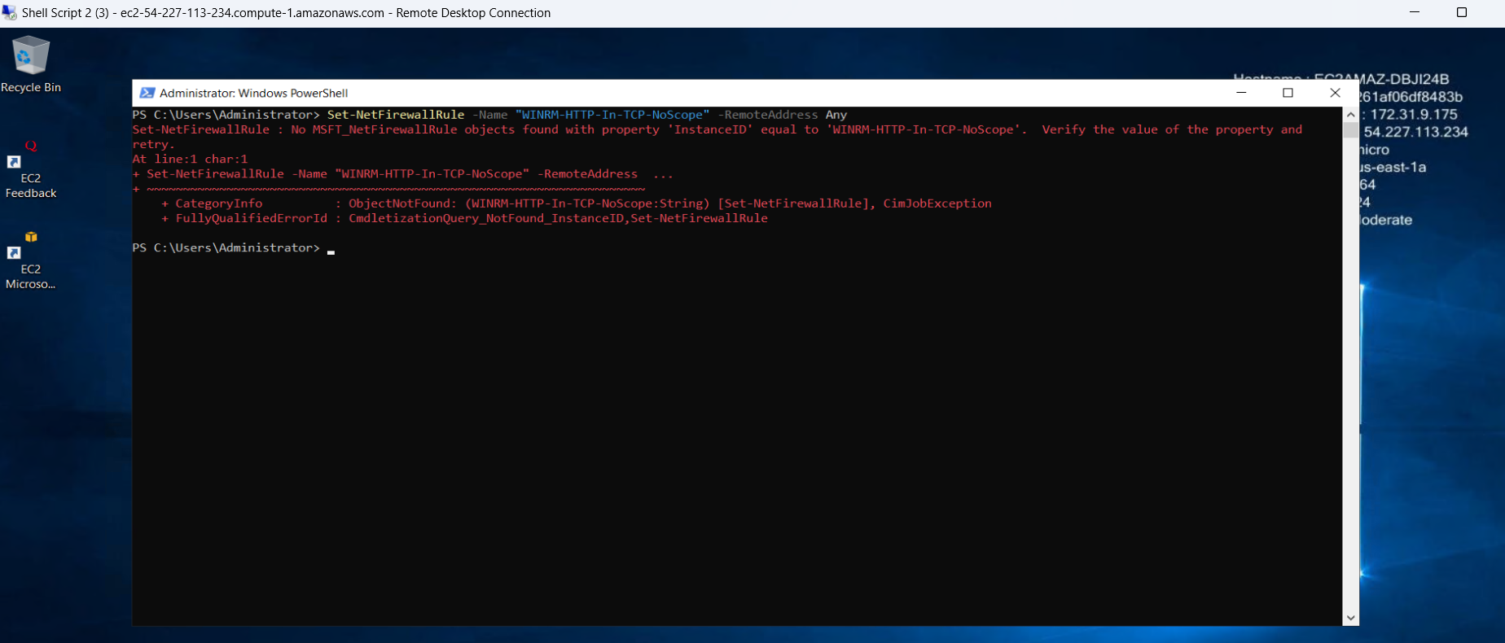

**6. Open Firewall Ports for WinRM**

Creates firewall rules to allow inbound connections on specific TCP ports (5985 for HTTP and 5986 for HTTPS).

**New-NetFirewallRule -Name WinRM-HTTP-In-TCP -DisplayName 'WinRM HTTP Inbound' -Enabled True -Direction Inbound -Protocol TCP -LocalPort 5985**

**New-NetFirewallRule -Name WinRM-HTTPS-In-TCP -DisplayName 'WinRM HTTPS Inbound' -Enabled True -Direction Inbound -Protocol TCP -LocalPort 5986**

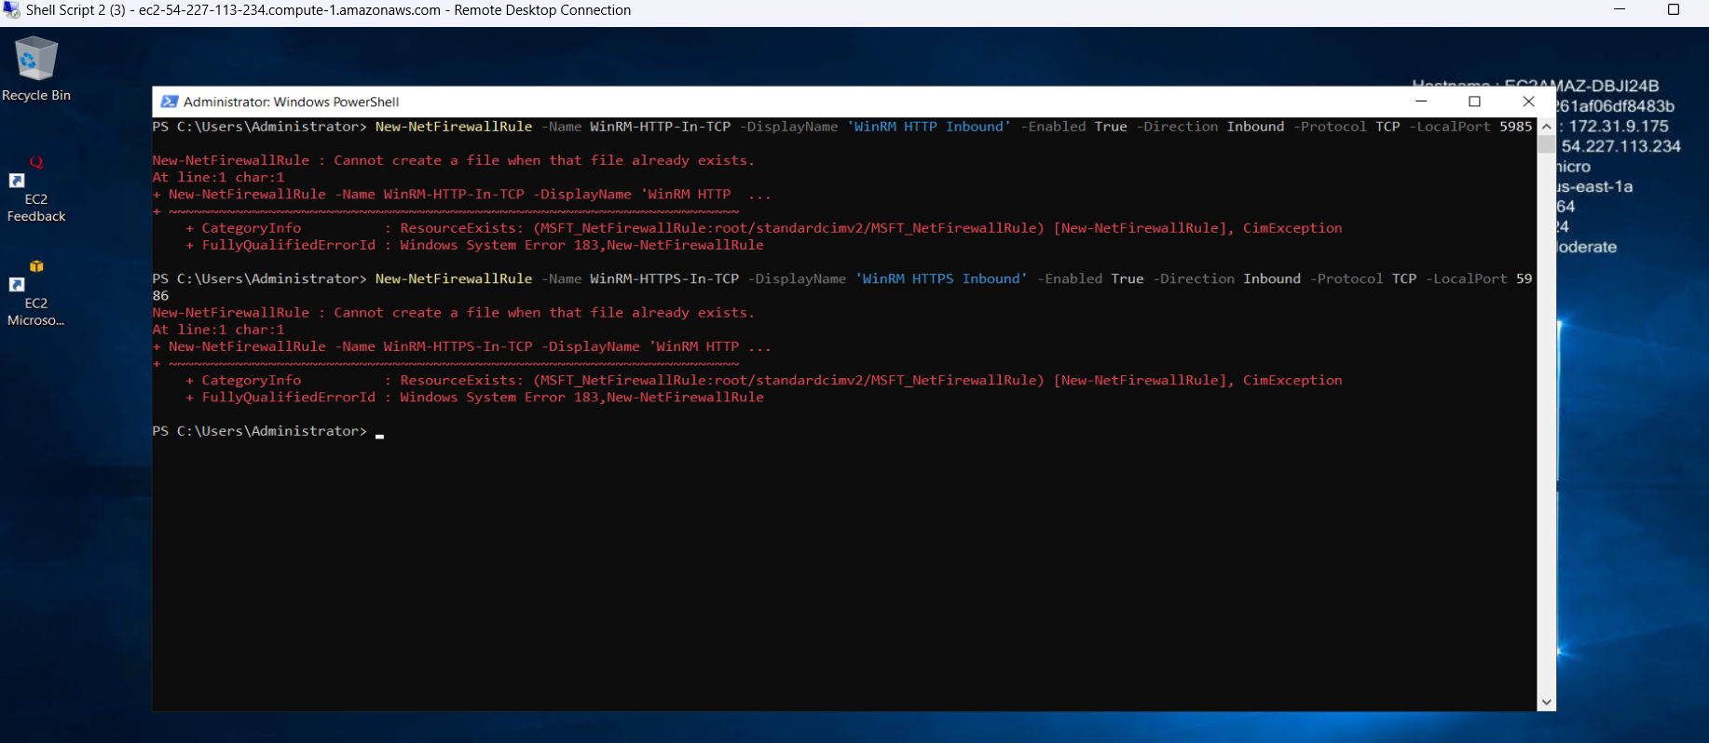

**We are getting this error because I am hitting the same command twice.**

**7. Check WinRM Configuration**

Displays the current WinRM configuration settings.

**winrm get winrm/config**

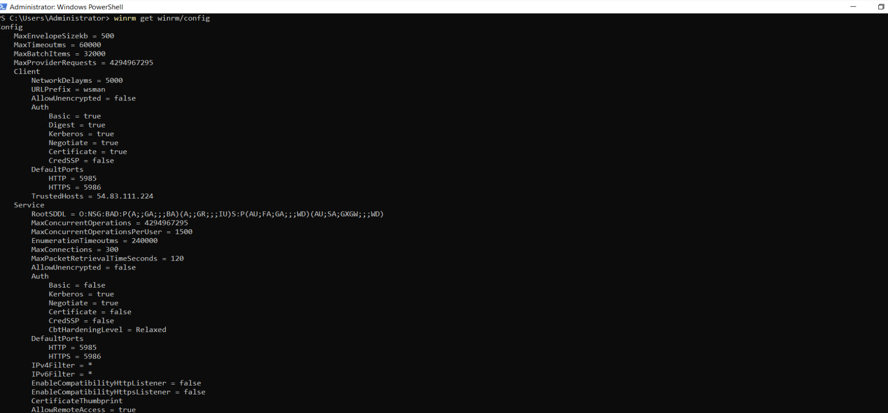

**8. Configure Trusted Hosts on Local Computer**

Sets the trusted hosts on the local computer for WinRM communication.

**winrm set winrm/config/client '@{TrustedHosts="remote_host_ip"}'**

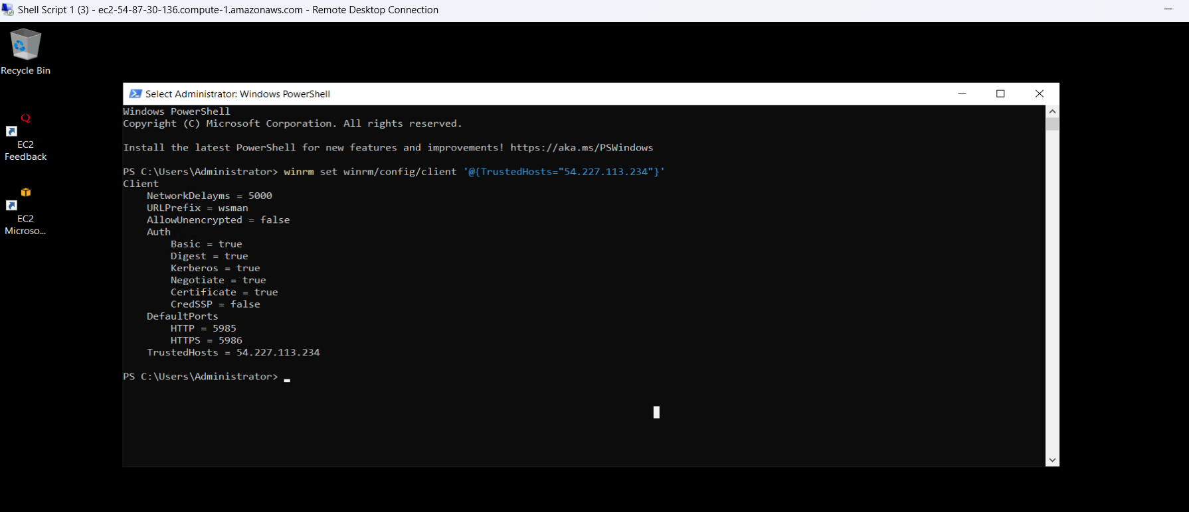

**9. Configure Credentials on Local Computer**

Sets the credentials on the local computer to invoke the command directly.

**$credential = New-Object System.Management.Automation.PSCredential ("Administrator", (ConvertTo-SecureString -String "2JVbshDWj3r?HwZmgcN3NV3!3yz;9F5l" -AsPlainText -Force))**

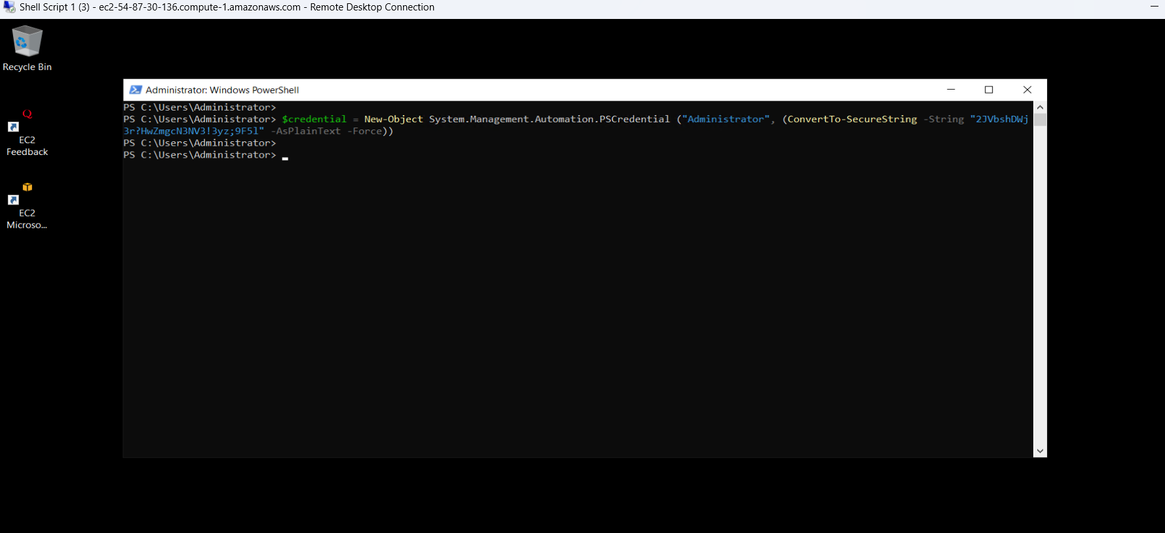

**10. Execute Script on Remote Computer**

Runs a PowerShell script on the remote computer using the Invoke-Command cmdlet and specifying the script block and credentials.

**Invoke-Command -ScriptBlock {C:\Users\Administrator\Downloads\Script.ps1} -ComputerName 54.227.113.234 -Credential $credential**

